Multiple choice section – choose the correct answer

Question 1 [6.1]

For the triangle shown, the opposite side is:

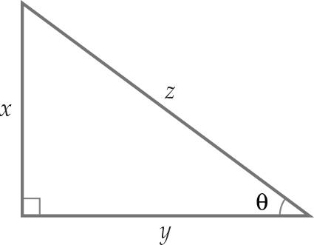

A x B y C z D θ

Question 2 [6.1]

For the triangle shown, the hypotenuse is:

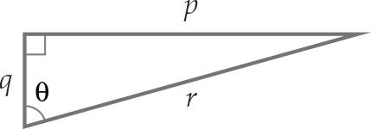

A θ B r C p D q

Question 3 [6.1]

For the triangle shown, the trigonometric function that you would choose is:

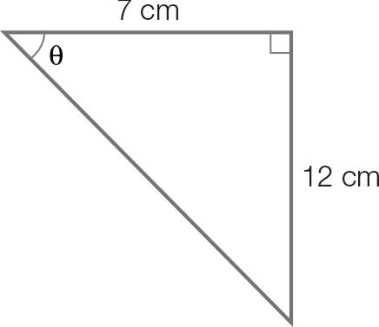

A sin (θ) = B cos (θ) = C tan (θ) = D a2 + b2 = c2

Question 4 [6.1]

For the triangle shown, the trigonometric function that you would choose is:

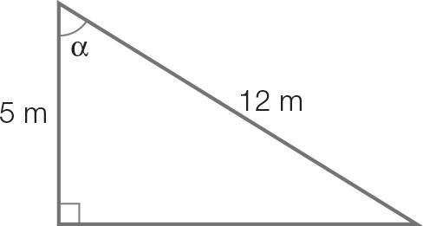

A a2 + b2 = c2 B sin (α) = C cos (α) = D tan (α) =

Question 5 [6.2]

The value of x is closest to:

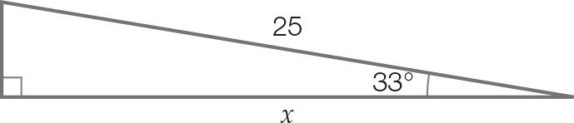

A 14 B 21 C 29 D 16

Question 6 [6.2]

The value of y is closest to:

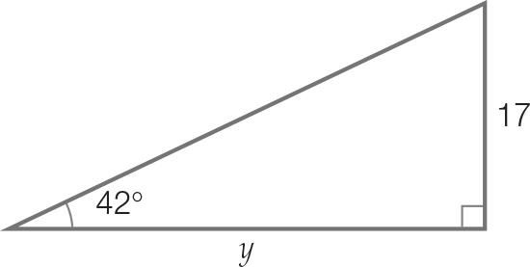

A 19 B 15 C 23 D 25

Question 7 [6.3]

The value of θis closest to:

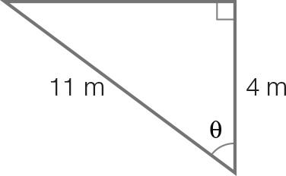

A 3 B 20 C 22 D 69

Question 8 [6.5]

The following angle as a compass bearing is:

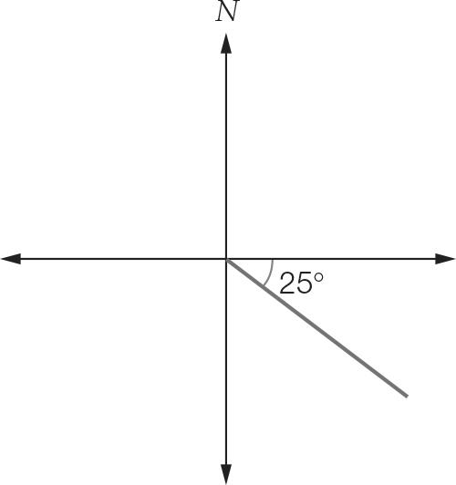

A 025°T B S65°E C E25°S D 115°T

Multiple-choice total marks: ___ / 8

Short answer section

Question 9 4 marks [6.6]

(a) Using Pythagoras’ theorem, a2 = c2 – b2, find the value of a. Write your answer correct to 1 decimal place.

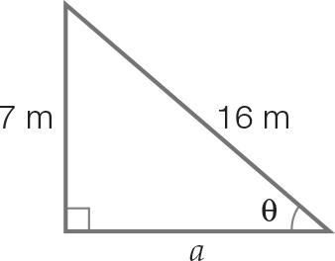

(b) Find the value of θ. Write your answer correct to the nearest degree.

Question 10 4 marks [6.2, 6.3]

(a) Find the value of x. Write your answer correct to 1 decimal place.

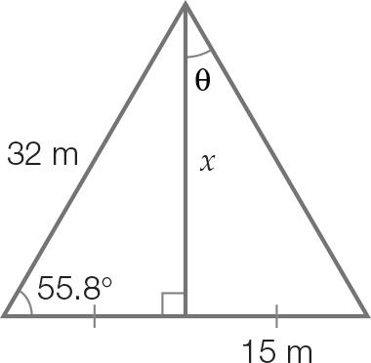

(b) Find the value of θ. Write your answer correct to 1 decimal place.

Question 11 2 marks [6.4]

Having some trouble with his smartphone reception, Jensen holds his phone up. The angle of elevation between his eye and the phone is 48, and the height is as shown in the diagram below. Calculate the distance that the phone is now away from his eye. Write your answer to the nearest centimetre.

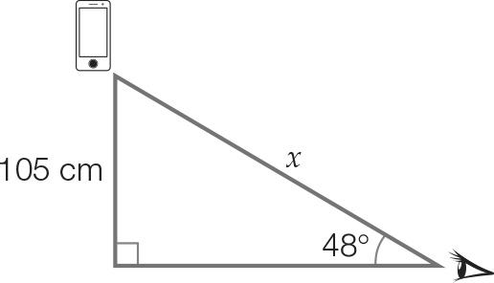

Question 12 2 marks [6.4]

A lifesaver is sitting in an 18 m tall tower and sees a swimmer in distress. The angle of depression to a swimmer is 34. Calculate the horizontal distance, correct to 1 decimal place, the lifesaver must travel to reach the swimmer.

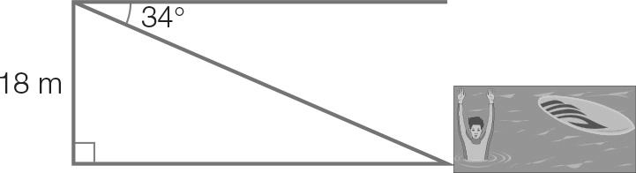

Question 13 2 marks [6.5]

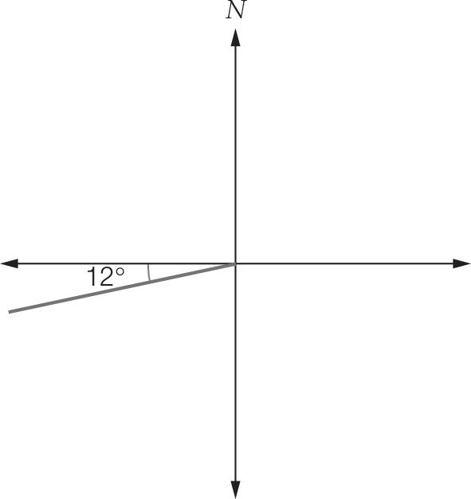For the angle shown on the right, write the:

(a) compass bearing

(b) true bearing

Question 14 4 marks [6.5]

A bushwalker walks due south for 13 km. As shown on the diagram he then walks due east. He finds a path that will get him back to the starting point, it is on a bearing of S38E.

(a) How far east has he walked? Write your answer correct to one decimal place.

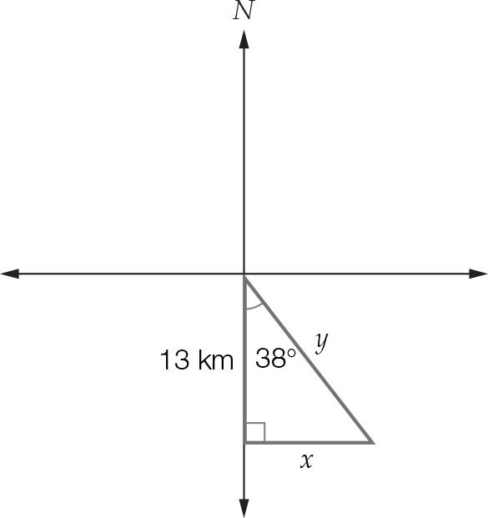

(b) How far does he need to walk if he walks back in a straight line? Write your answer correct to one decimal place.

Question 15 7 marks [6.6]

A ladder leaning overhangs a wall and makes an angle of 35° with the ground. The end of the ladder touches the top of the tree.

(a) What is the height of the wall, correct to two decimal places?

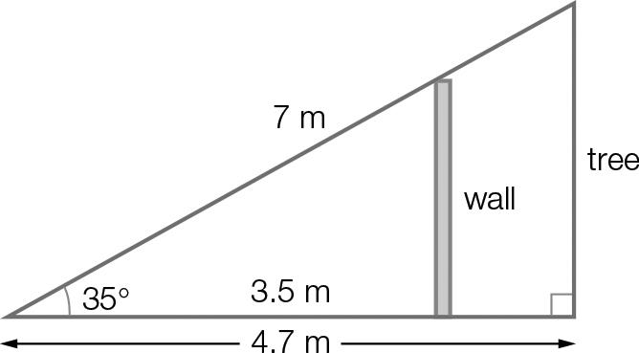

(b) How many centimetres of the ladder overhangs the wall?

(c) How much taller than the wall is the tree?

Short answer total marks: ___ / 25

Extended response section

Question 16 5 marks [6.6]

Camilla dives off board 1, which is 2.8 m above the pool and her hands make contact with the water 6.7 m from the base of the board.

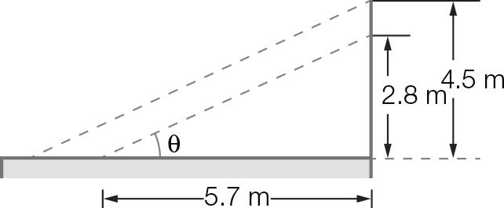

(a) Assuming Camilla’s diving trajectory was a straight line, at what angle, θ, to the horizontal did she hit the water? Answer correct to the nearest degree.

(b) Camilla climbs up to board 2 and dives, entering the water at the same angle as before. How much farther did she hit the water than her first dive? Answer correct to 1 decimal place.

Question 17 6 marks [6.6]

A crane lifts a container 1.2 m above the ground.

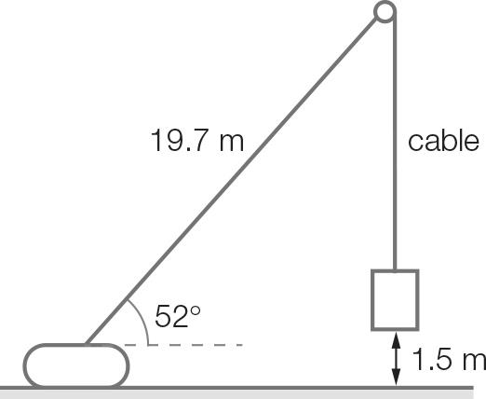

(a) What is the length of the vertical cable? Answer correct to 2 decimal places.

(b) The crane is moved 5 m closer to the container. At what angle, correct to 1 decimal place, should the crane operate so that the container remains in the same position and the same height as previously?

Extended answer total marks: ___ / 11

TOTAL test marks: ___ / 44